Parent Information
Welcome to Youth Eco Solutions (YES!) 2018-2019!
The mission of YES! is to empower youth to partner with their community to create economic and environmental vitality through hands-on learning and team-based projects.

YES! provides a unique opportunity for students to learn by engaging directly in community efforts that lead to dramatic demonstrations of renewable energy technology and conservation practices and exposes them to real-life applications of science.

Key Objectives of YES!
- Engage youth and empower them to take positive action in their communities
- Develop leadership, community-building, and problem-solving skills
- Increase awareness of career, economic and entrepreneurial opportunities
- Increase knowledge of energy and environmental issues and opportunities
- Create sustainable communities
YES! Activities & Events
YES! works with youth to form teams that do energy action projects in schools and communities, leading to cost savings, energy savings, and sustainability improvements. Team projects have included energy conservation initiatives, solar and small wind, recycling and composting, school and community gardens, education efforts, and more! YES! Coordinators visit with teams throughout the year to assist and support teams. Staff members are also available as resources to the teams throughout the season.

Participants make connections with experts throughout the season to assist with education, connection, and their energy action projects. Students attend the annual Fall Summit to kick off their season and gain information and inspiration for their projects. During the winter, teams meet again at the Winter Workshops and participate in tours and activities to meet the needs of their team. Each spring, teams are recognized for their accomplishments.

Please Note: Meals may be provided at YES! events. Please be sure coaches are aware of any dietary restrictions your student may have so they can be included on the attendance form.

Liability Release Form
A YES! liability release form (on reverse side) must be signed by a parent or guardian for your student to participate in this program. Please visit www.yesmn.org for YES! staff contact information and ongoing updates on the program.

Thank you for supporting your student and YES! team as they work to put energy into our future!

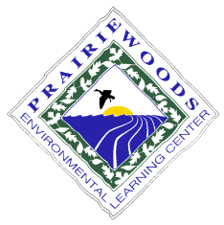
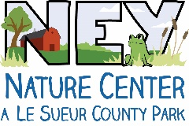
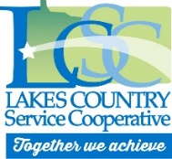
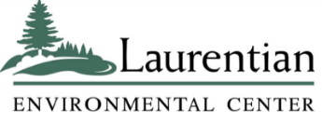

As parent or guardian of the student named below, I give my permission for my child to attend the Youth Eco Solutions (YES!) program activities at Prairie Woods Environmental Learning Center (PWELC), Laurentian Environmental Center (LEC), Ney Nature Center (NNC), Lakes Country Service Cooperative (LCSC), and other locations as scheduled through the YES! program. I give permission for PWELC, LEC, NNC, LCSC, or the school or organization named below to provide transportation to my child for emergency or educational reasons. In the event of an emergency, I authorize the administration of basic first aid. I also authorize appropriate treatment by emergency medical personnel.

In consideration of my child’s participation in the YES! program, by signing this release, I agree that if my child is injured in any way while participating in activities at PWELC, LEC, NNC, LCSC, or other locations scheduled through the YES! program, I voluntarily release PWELC, Kandiyohi County, LEC, NNC, LCSC, the school or organization named below, as well as all of their personnel, staff and directors, from any and all liability except from gross negligence or willful or wanton conduct for the injuries.

I understand and agree that this release applies to not only me, but also my estate, heirs and assigns. In the event some other person or entity seeks compensation for these released liabilities, my estate or I, will indemnify and hold harmless PWELC, Kandiyohi County, LEC, NNC, LCSC, and the school or organization named below.

I understand that activities may include but are not limited to the following: touring industrial facilities, hiking on uneven ground, exposure to dangerous weather and other natural conditions, walking on docks or boardwalks over open water, canoeing, participating in supervised climbing wall or high rope activities, or other activities. I am aware that participants may be injured while participating in these and other activities. I have determined that my child is fully medically capable of participating in activities through YES!.

All references in this form to activities through PWELC, LEC, NNC, and/or LCSC include activities at satellite or off-facility locations and community action projects.

As a parent or guardian of this student, I give consent to the use of their image in photographs/videotape taken during the course of the school year for publicity, promotional and/or educational purposes including publications, presentation or broadcast via newspaper, internet, or other media sources). I do this with full knowledge and consent and waive all claims for compensation for use, or for damages.

By signing below, I acknowledge that I have read this release; I understand it; and I fully agree to all of its terms.

Signature of parent/guardian: Date:
Name of parent or guardian (print): _______________________________ Email: ___________________
Student’s Name (print): Age: Email:
Name of school or organization involved in YES!:
City/town where student lives:
E-Newsletter Sign-up (would you and/or your student like to receive our quarterly e-newsletter with information about the YES! program?)
☐Please sign parent up
☐Please sign student up

